**Web Application Development _CS 486T Project**

|  |  |  |
| --- | --- | --- |
| **Student Name** | **Student Academic Number** | **Student E-mail** |
| Reem Ahmed AlRashed | 436000234 | 436000234@pnu.edu.sa |
| Ghadah Fahad Almuqren | 437003862 | 437003862@pnu.edu.sa |
| Shahad Fahad Albunayyih | 437004549 | 437004549@pnu.edu.sa |

Book store

7C7

Computer Science Department

First Semester 2019\2020

**For Instructor Use Only**

**Student Name**:Reem Ahmed AlRashed **Academic Number**: 436000234

|  |  |  |  |
| --- | --- | --- | --- |
| **PLO** | **Max Mark** | **Marks Obtained** | **Note** |
|  |  |  |  |
|  |  |  |  |
|  |  |  |  |
| **Total Score** | **15** |  |  |

**Student Name**:Ghadah Fahad Almuqren **Academic Number**: 437003862

|  |  |  |  |
| --- | --- | --- | --- |
| **PLO** | **Max Mark** | **Marks Obtained** | **Note** |
|  |  |  |  |
|  |  |  |  |
|  |  |  |  |
| **Total Score** | **15** |  |  |

**Student Name**: Shahad Fahad Albunayyih **Academic Number**: 437004549

|  |  |  |  |
| --- | --- | --- | --- |
| **PLO** | **Max Mark** | **Marks Obtained** | **Note** |
|  |  |  |  |
|  |  |  |  |
|  |  |  |  |
| **Total Score** | **15** |  |  |

* **Proposal:**

The ability for a customer to buy books online provides him/her with an ultimate personal experience. It makes it possible for anyone to buys books that are compatible with their specific interests on any day and at any time. Online bookstores have altered how readers and writers interact and are expected to have a massive impact on the book retail business in the future. They do not require physical access and are open for 24 hours. Managing of inventory in the shop for shopkeeper becomes easier as customers are not visiting and ordering online.

This system saves both time and travelling cost of customers.

User can get to know different kinds of books that they were unaware of just by opening the website and going throw the books list.

So that's why we are proposing a bookstore website to provide our customers with the best service quality. Website applications have many advantages, such as:

1. websites are accessible from any internet-enabled computer.
2. Usable with different operating systems and browser platforms.

And many other advantages that outweigh the disadvantages we chose it to be a website rather than a desktop application.

* **Brief description of your web site:**

This website allows the customer to get their book delivered instead of actually going and buying the book. This will be by only signing in to create an account then log in the system. After that, the customer will add his contact information, such as address and phone number. Then he can add books to cart, view cart and finally check out. The payment will be Cash on Delivery (COD). Delivery price will be free since books are a bit expensive. Admin adds books, and he has an independent interface. Admin can log in the system view customers information, available books and add books to them as well.

* **System requirements:**
  1. **The system consists of two users :** Admin and customer.
  2. **Functional Requirements:**

**Admin:**

* + - log in .
    - View customers information.
    - Add book .
    - View Available books.
    - View Customers information.
    - Log out.

**Customer:**

* + - Sign in.
    - log in.
    - Add customer information.
    - View available books.
    - Add book to cart.
    - View cart.
    - Checkout.
    - Log out.
* Non-functional requirements:
  + **Availability:** Percentage of time that system can be used to accomplish normal tasks.
  + **Usability:** The system should be easy and user-friendly.
  + **Security:** Security is obtained by ensuring that no one can access system except for authorized people by username and password.
  + **Privacy:** Privacy is that each user can see only his related information.
* **Use case diagram:**
* 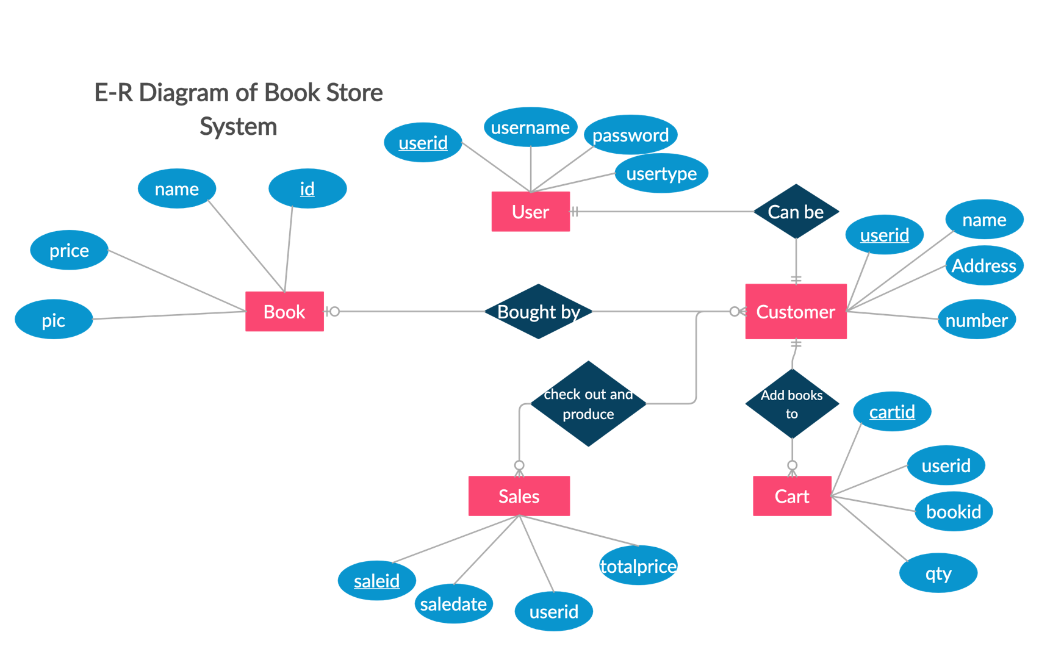Database design:
* We have 5 main entities’ for our database
  1. User, to store admin and customer login data (username , password) and usertype to differentiate between them.
  2. Customer , to store customer’s communication information.
  3. Book , to store available books associated with their id , name , price and picture.
  4. Cart , to store cartid , userid that added book to cart , bookid that is added to cart and qty of book added.
  5. Sales, to store information after checkout such as saleid , saledate , userid to identify which user checked out and finally the totalprice.

We implemented it using XAMPP phpMyAdmin.

**Database name : BookStore.**

**User table:**

**Customer table:**

**Book table:**

**Cart table:**

**Sales table:**

* **Screenshots of the website:**

Home Page : for admin and customer login.

**Admin:**

* **Login page:** Admin enters his username , password and choose his usertype.

* **Admin Home page:** It contains welcoming message and admin service .

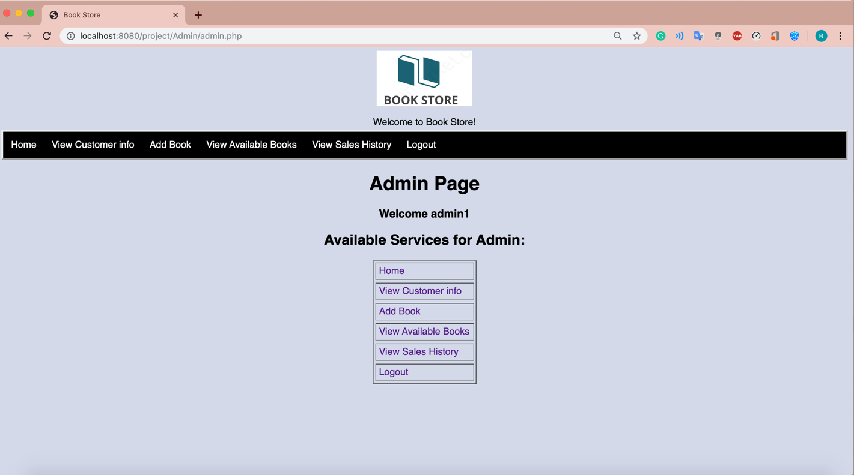

* **View Customer info page:** it contains registered customers information.

* **Add book:** it contains form for adding books.

After clicking Add Book button:

* **View Available books:** it contains table that shows available books.

* **View Sales History:** it contains sales table.

* **Log out:** redirect and go to home page again first click logout

Then it will go to home page.

**Customer:**

**Assuming that user is not signed in the system**

* **Login page:** Customer click on sign in

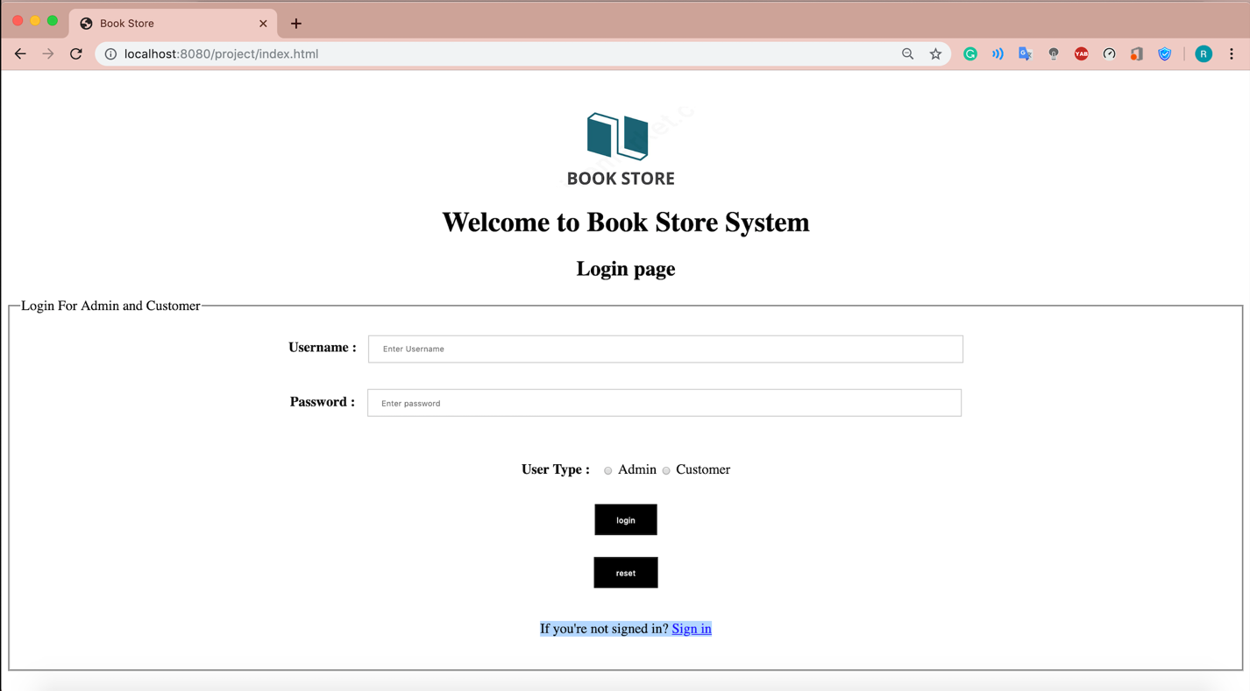

Customer will be directed to sign in page and enter his information

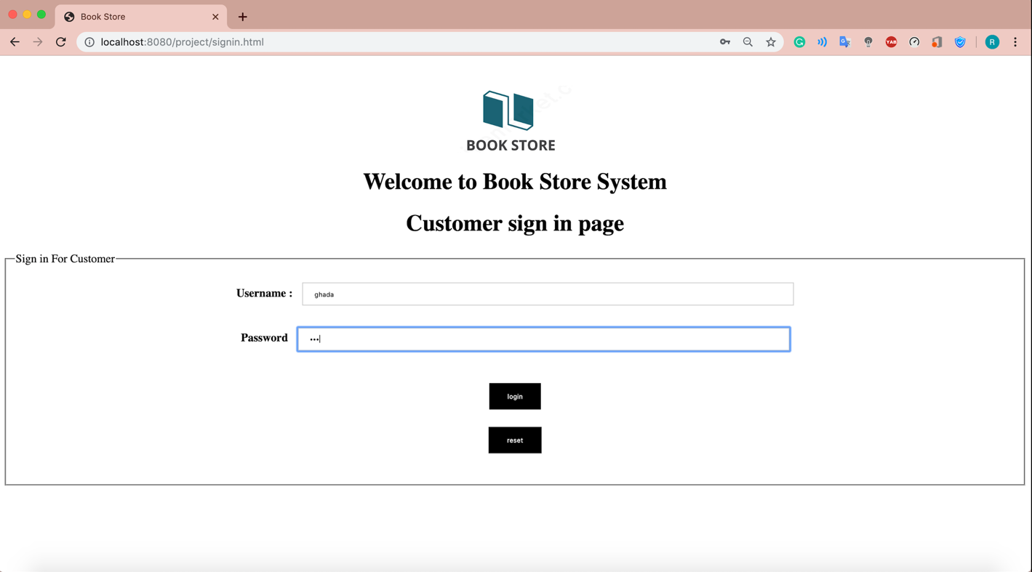

Then when customer press on login button his username and password will be stored in database and he will be redirected to home page

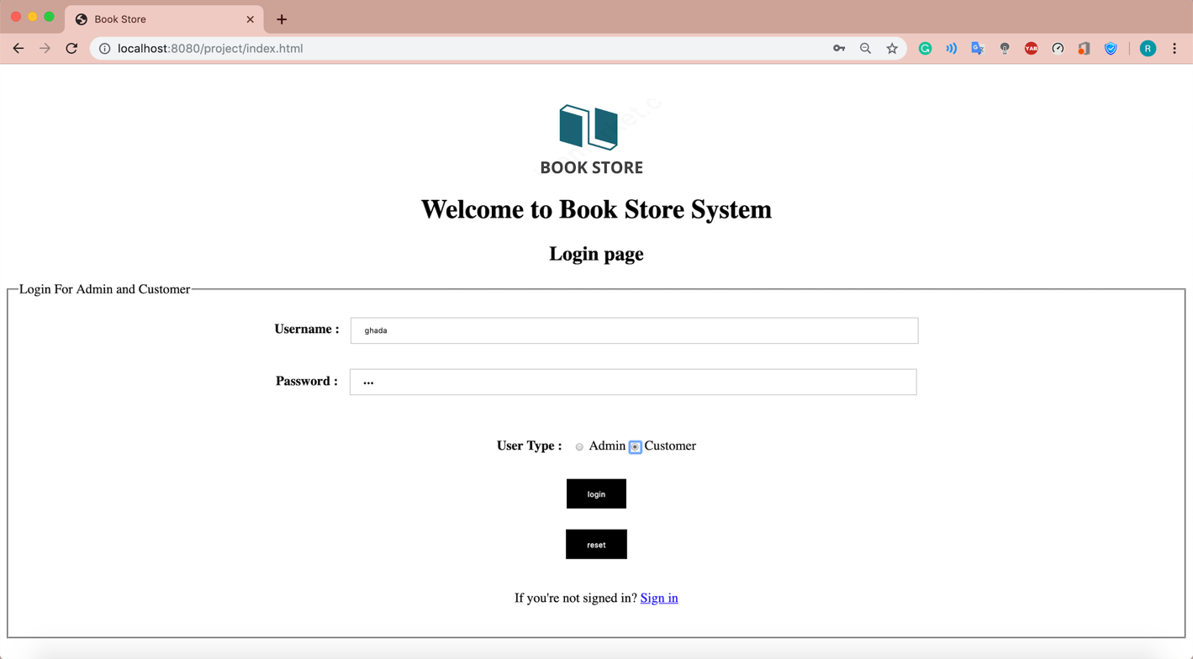

* **Customer Home page:** It contains welcoming message and available books .

* **About us:** it contains information about the website.

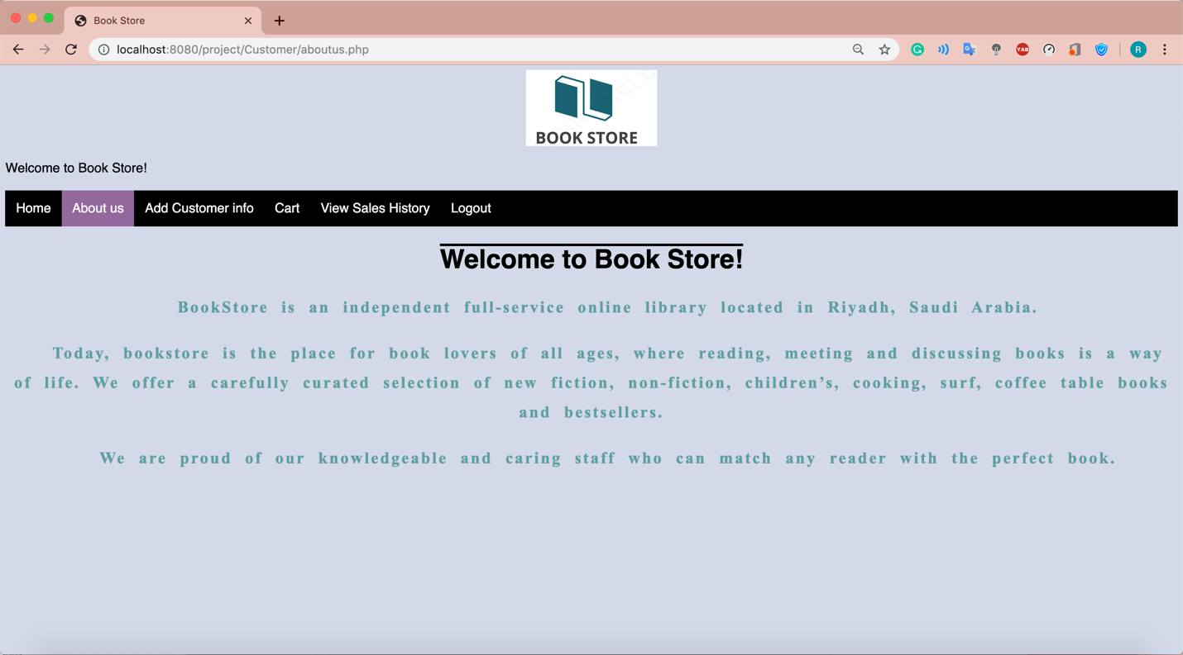

* **Add Customer info:** it contains form for adding customer’s information.

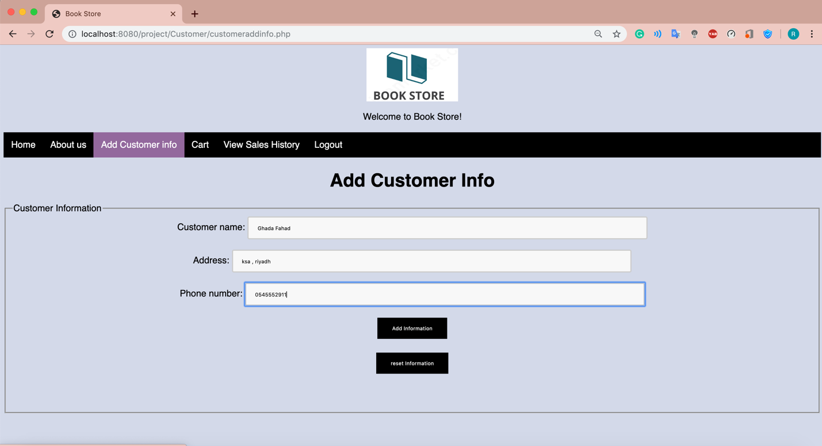

Clicking add information button

* **Cart page:** it contains books added on cart.

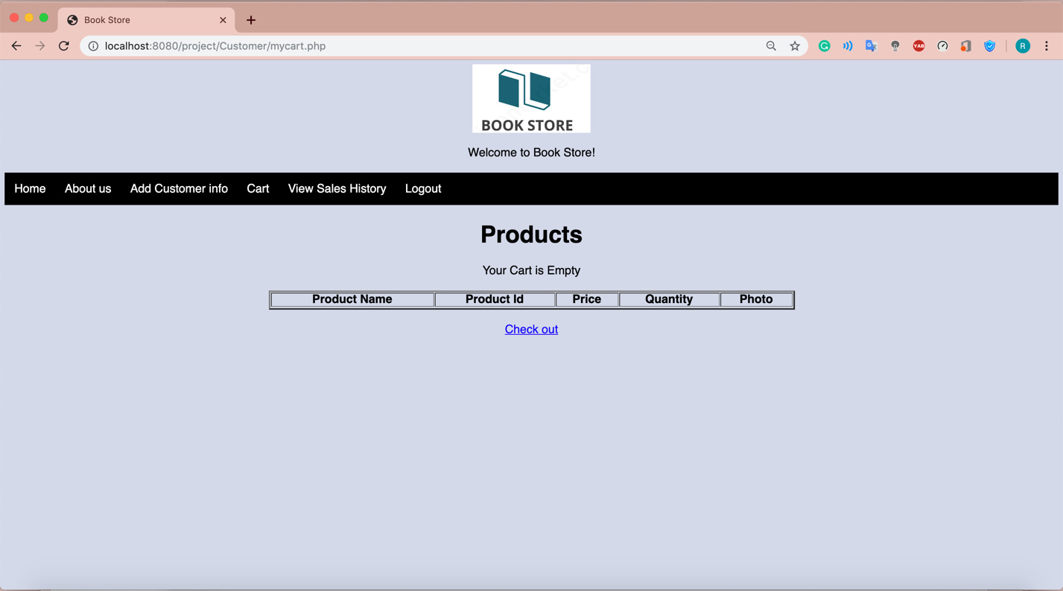

Then customer can go back to home page and add books:

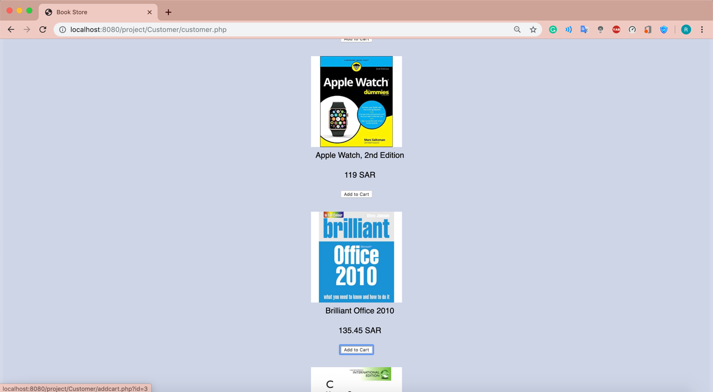

Adding another book:

Then going to **Cart** page:

Checkout page:

* **View Sales History:** it contains sales table.

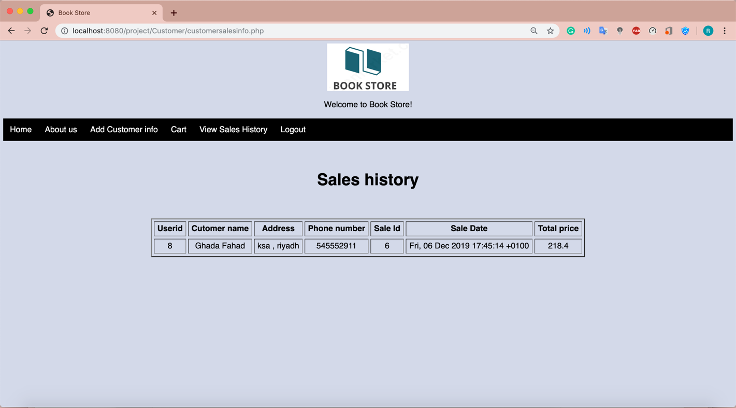

* **Log out:** redirect and go to home page again first click logout

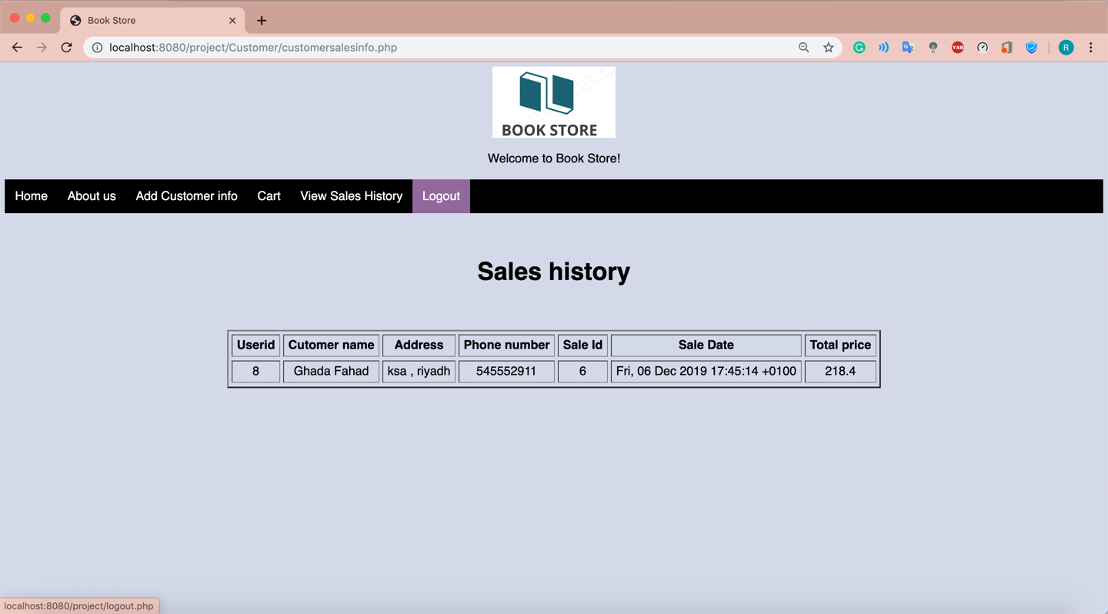

Then it will go to home page.

* Future work:
* As an enhancement to our website, we may allow customers to post reviews about books. This will benefit other customers. Feedback will affect the ratings of the book online, especially for rare books, and will make for a unique interactive shopping experience that will attract other customers to the site. Moreover, we could add technical support conversation between admins and customers.
* Appendix:
* Code:
* **session.php page : to start a session for admin and user**

|  |
| --- |
| <?php  session_start();  $_SESSION['bookid'];  $host = "localhost"; /* Host name */  $user = "root"; /* User */  $password = ""; /* Password */  $dbname = "BookStore"; /* Database name */  $con = new mysqli($host, $user, $password,$dbname);  // Check connection  if (!$con) { die("Connection failed: " . connect_error); }  if (!isset($_SESSION['id']) ||(trim ($_SESSION['id']) == '')) {  header('location:../index.php');  exit(); }  $sql=mysqli_query($con,"select * from User where userid='".$_SESSION['id']."'");  $srow=mysqli_fetch_array($sql); $user=$srow['username'];  ?> |

**Index.html page : login for admin and customer form**

|  |
| --- |
| <html><head><title>Book Store</title>  <link href="css/loginformstyle.css" rel="stylesheet">  <style>  body{text-align:center;}</style>  </head>  <body> <br/><br/> <div class="logo">  <img src="pic/logo.png" width="200" alt="logo">  </div> <h1>Welcome to Book Store System</h1>  <h2>Login page</h2>  <form name="loginForm" method="POST" action="login.php">  <fieldset> <legend>Login For Admin and Customer </legend>  <div class="container">  <label for="uname"><b>Username :</b></label>  <input type="text" placeholder="Enter Username" name="username" required><br/><br/>  <label for="psw"><b>Password : </b></label>  <input type="password" placeholder="Enter password"name="password" required><br/><br/><br/>  <label for="usertype"><b>User Type : </b></label> <input type="radio" name="usertype" value="Admin"> Admin  <input type="radio" name="usertype" value="Customer"> Customer<br/><br/>  <input type="submit" value="login"><br/><br/>  <input type="reset" value="reset"><br/><br/>  <p>If you're not signed in? <a href="signin.html">Sign in</a></p>  </fieldset></div></form></body></html> |

**login.php page : login for admin and customer php code**

|  |
| --- |
| <?php session_start();  $host = "localhost"; /* Host name */  $user = "root"; /* User */  $password = ""; /* Password */  $dbname = "BookStore"; /* Database name */  $con = new mysqli($host, $user, $password,$dbname);  // Check connection  if (!$con) {die("Connection failed: " . connect_error);}  $username=$_POST["username"]; $password=$_POST["password"];  $usertype=$_POST["usertype"]; $logged_in=false;  $sql="SELECT * FROM User WHERE username='$username' and  password='$password' and usertype='$usertype'";  $result=$con->query($sql);  if($result->num_rows==1){  $row=$result->fetch_assoc();  $logged_in=true;  if($row['usertype']=="Admin"){  $_SESSION['id']=$row['userid'];  header("location:Admin/admin.php"); }  else if($row['usertype']=="Customer"){  $_SESSION['id']=$row['userid']; ("location:Customer/customer.php"); } }  if(!$logged_in){ echo 'Wrong information'; } ?> |

**signin.html page : signin for customer form**

|  |
| --- |
| <html>  <head><title>Book Store</title>  <link href="css/loginformstyle.css" rel="stylesheet">  <style>body{text-align:center;}  </style> </head>  <body> <br/><br/> <div class="logo"> <img src="pic/logo.png" width="200" alt="logo"> </div> <h1>Welcome to Book Store System</h1><h1>Customer sign in page</h1>  <form name="SigninForm" method="POST" action="signin.php">  <fieldset> <legend>Sign in For Customer </legend> <div class="container">  <label for="uname"><b>Username :</b></label>  <input type="text" placeholder="Enter Username" name="username" required><br/><br/>  <label for="psw"><b>Password</b></label>  <input type="password" placeholder="Enter password"name="password" required><br/><br/><br/>  <input type="submit" value="login"><br/><br/> <input type="reset" value="reset"><br/><br/> </fieldset></form>  </body>  </html> |

**signin.php page : signin for customer php code**

|  |
| --- |
| <?php  $host = "localhost"; /* Host name */  $user = "root"; /* User */  $password = ""; /* Password */  $dbname = "BookStore"; /* Database name */  $con = new mysqli($host, $user, $password,$dbname);  // Check connection  if (!$con) { die("Connection failed: " . connect_error); }  $username=$_POST["username"];  $password=$_POST["password"];  $usertype="Customer";  $sql="insert into User(username,password,usertype)  values('$username','$password','$usertype')";  if($con->query($sql)===TRUE){ ?>  <script type='text/javascript'>  alert("Sign is done correctly , you can log in now");  </script>  <?php header("location:index.html"); } else{?>  <script type='text/javascript'>  alert("Sign in have problem , try again");  </script> <?php }  $con->close();  ?> |

**logout.php page : logout for admin and customer php code**

|  |
| --- |
| <?php  header('location:index.html');  ?> |

**Admin:**

**Admin home page : admin.php**

|  |  |
| --- | --- |
| <?php include("adminnav.html");  include('session.php'); ?>  <html><head>  <title>Book Store</title>  <style>  body,h2,li{ text-align: center; }  ul{ list-style-position: inside; align-content: center; margin: 5; border-style: outset;  text-align: center; border-top-width: medium; border-bottom-width: medium;}  tr:hover {background-color: #f5f5f5;}  a:link { text-decoration: none;}  a:visited { text-decoration: none;}  a:hover { text-decoration: underline;} a:active { text-decoration: underline;}  </style>  </head>  <body>  <h1>Admin Page</h1>  <h3> Welcome <?php  $sql="select * from User where userid='".$_SESSION['id']."' ";  $result=$con->query($sql);  if($result->num_rows>0){  while($row=$result->fetch_assoc()){ | echo $row['username'];  }}  ?> </h3>  <h2>Available Services for Admin:</h2>  <table align='center' border="1" cellpadding="7" cellspacing="5">  <tr> <td> <a href="admin.php">Home </a> </td></tr>  <tr> <td> <a href="customerinfo.php">View Customer info </td></tr>  <tr> <td><a href="addProductForm.php">Add Book </a> </td></tr>  <tr> <td> <a href="viewbookinfo.php">View Available Books </a> </td></tr>  <tr> <td> <a href="salesinfo.php">View Sales History </a> </td></tr>  <tr> <td> <a href="../logout.php">Logout</a></td></tr>  </table>  </body>  <html> |

**View Customer info page : customerinfo.php**

|  |  |
| --- | --- |
| <?php include("adminnav.html");include('session.php'); ?>  <html><head><title>Book Store</title>  <link href="../css/tablestyle.css" rel="stylesheet">  <style>body{text-align:center;}  table{ text-align:center;}</style></head><body> <br/><br/>  <h1>View Customers Info</h1></body></html>  <?php  $host = "localhost"; /* Host name */  $user = "root"; /* User */  $password = ""; /* Password */  $dbname = "BookStore"; /* Database name */  $con = mysqli_connect($host, $user, $password,$dbname);  // Check connection  if (!$con) { die("Connection failed: " . connect_error);}  echo "<table border='3'align='center'cellspacing='5' cellpadding='7''>";  $sql="select * from User left join Customer on Customer.userid=User.userid and User.usertype='Customer'";  $result=$con->query($sql); | if($result->num_rows>0){  echo "<tr><th>Customer Name</th> <th>Customer Address Type</th>  <th>Customer Phone Number </th> <th>username</th> </tr>";  while($row=$result->fetch_assoc()){  if($row['usertype']=="Customer"){  echo "<tr>";  echo "<td>".$row['name']."</td>";  echo "<td>".$row['address']."</td>";  echo "<td>".$row['number']."</td>";  echo "<td>".$row['username']."</td>";  echo "</tr>";  }  }  }  echo "<br/><br/>";  echo "</table>";  ?> |

**Add Book form page : addProductForm.php**

|  |
| --- |
| <?php include("adminnav.html"); ?>  <html><head><title>Book Store</title>  <link href="../css/formstyle.css" rel="stylesheet">  <style>body{text-align:center;}</style></head>  <body> <br/><br/> <h1>Add Book page</h1>  <form name="AddBookForm" method="POST" action="addproduct.php">  <fieldset> <legend >Book adding form</legend>  Book id : <input name="bookid" type="text"> <br/><br/>  Book name:<input name="bookname" type="text"> <br/><br/>  Book price: <input type="text" name="price"><br/><br/><br/><br/>  Book Picture URL : <input type="url" name="pic" id="picurl" width="50%"><br/><br/><br/><br/>  <input type="submit" value="Add Book"><br/><br/>  <input type="reset" value="Reset"><br/><br/> </fieldset></form></body></html> |

**Add Book php: addproduct.php**

|  |  |
| --- | --- |
| <?php  $host = "localhost"; /* Host name */  $user = "root"; /* User */  $password = ""; /* Password */  $dbname = "BookStore"; /* Database name */  $con = new mysqli($host, $user, $password,$dbname);  if (!$con) {die("Connection failed: " . connect_error);}  $id = $_POST["bookid"];  $name=$_POST["bookname"];  $price=$_POST["price"]; | $pict=$_POST["pic"];  $sql="insert into Book (id,name,price,pic)values('$id','$name','$price','$pict')";  if($con->query($sql)===TRUE){ ?>  <script type='text/javascript'>  alert("Book is added successfuly");  window.history.back(); </script>  <?php }  else{ ?> <script type='text/javascript'>  alert("Book is already added ");  window.history.back();</script>  <?php }  $con->close(); ?> |

**View Available books page: viewbookinfo.php**

|  |  |
| --- | --- |
| <?php include("adminnav.html");  include('session.php'); ?>  <html>  <head>  <title>Book Store</title>  <link href="../css/tablestyle.css" rel="stylesheet">  <style>body{text-align:center;}  </style>  </head>  <body> <br/><br/><h1>View Available Books Info</h1></body></html>  <?php  $host = "localhost"; /* Host name */  $user = "root"; /* User */  $password = ""; /* Password */  $dbname = "BookStore"; /* Database name */  $con = mysqli_connect($host, $user, $password,$dbname);  // Check connection  if (!$con) {  die("Connection failed: " . connect_error);  }  echo "<table border='3' align='center' cellspacing='5' cellpadding='7''>";  $sql="select * from Book"; | $result=$con->query($sql);  if($result->num_rows>0){  echo "<tr><th> Name</th> <th>Id</th>  <th>Price </th> <th>Picture</th> </tr>";  while($row=$result->fetch_assoc()){  echo "<tr>";  echo "<td>".$row['name']."</td>";  echo "<td>".$row['id']."</td>";  echo "<td>".$row['price']."</td>";  ?> <td><img src="<?php echo $row['pic'];?>" height="150px" width="150px;"></td>  <?php  echo "</tr>";  }  }  echo "<br/><br/>";  echo "</table>";  ?> |

**View History of sales page: salesinfo.php**

|  |  |
| --- | --- |
| <?php include("adminnav.html");  include('session.php'); ?>  <html>  <head>  <title>Book Store</title>  <link href="../css/tablestyle.css" rel="stylesheet">  <style>body{  text-align:center;  }  </style></head>  <body><br/><br/><h1>History of sales</h1></body></html>  <?php  $host = "localhost"; /* Host name */ $user = "root"; /* User */ $password = ""; /* Password */  $dbname = "BookStore"; /* Database name */  $con = mysqli_connect($host, $user, $password,$dbname);  // Check connection  if (!$con) {  die("Connection failed: " . connect_error);}  echo "<table border='3'align='center'cellspacing='5' cellpadding='7''>"; | $sql="select * from Sales left join Customer on Customer.userid=Sales.userid";  $result=$con->query($sql);  if($result->num_rows>0){  echo "<h1> Sales history</h1>";  echo "<tr><th> Userid</th>  <th>Cutomer name </th> <th>Address</th> <th>Phone number</th><th>Sale Id</th> <th>Sale Date</th><th>Total price</th> </tr>";  while($row=$result->fetch_assoc()){  echo "<tr>";  echo "<td>".$row['userid']."</td>";  echo "<td>".$row['name']."</td>";  echo "<td>".$row['address']."</td>";  echo "<td>".$row['number']."</td>";  echo "<td>".$row['saleid']."</td>";  echo "<td>".$row['saledate']."</td>";  echo "<td>".$row['totalprice']."</td>";  echo "</tr>";  }  }  echo "<br/><br/>";  echo "</table>";  ?> |

**Admin navigation code: adminnav.html**

|  |
| --- |
| <html>  <head> <title>Book Store</title><link href="../css/navstyle.css" rel="stylesheet"> </head> <body> <header id="header"><div class="logo"><img src="../pic/logo.png" width="200" alt="logo">  </div> <br/> <aside>Welcome to Book Store!</aside>  <nav role="navigation" style="margin-bottom: 0">  <ul><li> <a href="admin.php">Home </a> </li>  <li> <a href="customerinfo.php">View Customer info </a> </li>  <li> <a href="addProductForm.php">Add Book </a> </li>  <li> <a href="viewbookinfo.php">View Available Books </a> </li>  <li> <a href="salesinfo.php">View Sales History </a> </li>  <li> <a href="../logout.php">Logout</a></li>  </ul> </nav> </body>  <html> |

**Customer:**

**Customer home page : customer.php**

|  |  |
| --- | --- |
| <?php include('session.php'); include('customernav.html'); ?>  <html lang="en"><head> <title>Book Store</title>  <link href="../css/style1.css" rel="stylesheet"> </head>  <body> <div class="container">  <div style="height: 80px;"></div><div>  <?php  $host = "localhost"; $user = "root";  $password = ""; $dbname = "BookStore";  $con = new mysqli($host, $user, $password,$dbname);  if (!$con) {  die("Connection failed: " . connect_error); }  echo "<h3> Welcome ";  $sql="select * from User where userid='".$_SESSION['id']."'";  $result=$con->query($sql);  if($result->num_rows>0){  while($row=$result->fetch_assoc()){  echo $row['username']; }}  echo " !</h3>";  $inc=4; $query=mysqli_query($con,"select * from Book");  while($row=mysqli_fetch_array($query)){  $inc = ($inc == 4) ? 1 : $inc+1; | if($inc == 1) echo "<div >"; ?>  <div class="col-lg-3" align='center'>  <div><img src="<?php echo $row['pic']; ?>" alt="book image" style="width: 230px; height:230px; padding:auto; margin:auto;">  <div style="height: 10px;"></div>  <div style="height:40px; width:230px; margin-left:17px;"><?php echo $row['name']; ?></div>  <div style="height: 10px;"></div>  <div style="height:40px; width:230px; margin-left:17px;"><?php echo $row['price']." SAR"; ?></div>  <div style="height: 10px;"></div>  <div style="margin-left:17px; margin-right:17px; padding-bottom:20px;">  <a href="addcart.php<?php echo '?id='.$row['id']; ?>">  <button type="button" > Add to Cart</button> </a></div></div></div>  <?php if($inc == 4) echo "</div><div style='height: 30px;'></div>"; }  if($inc == 1) echo "<div class='col-lg-3></div><div class='col-lg-3'></div><div class='col-lg-3'></div></div>";  if($inc == 2) echo "<div class='col-lg-3'></div><div class='col-lg-3'></div></div>";  if($inc == 3) echo "<div class='col-lg-3'></div></div>"; ?> </div></body>  </html> |

**About us page : aboutus.php**

|  |  |
| --- | --- |
| <?php include('session.php');  include('customernav.html');  ?>  <html>  <head>  <title>Book Store</title>  <link href="../css/navstyle.css" rel="stylesheet">  <style>  p {color: #5F9EA0; text-indent: 50px;  text-align: center; letter-spacing: 3px; line-height: 1.8;word-spacing: 10px;  font-family:"Times New Roman", Times, serif;  font-size: 25px;  font-weight: bold;}  h1 {text-decoration: overline;}  h2 { text-decoration: line-through;}  h3 { text-decoration: underline;}  </style>  </head>  <body>  <h1 align='center'>Welcome to Book Store!</h1>  <p>BookStore is an independent full-service online library located in Riyadh, Saudi Arabia.</p> | <p>Today, bookstore is the place for book lovers of all ages, where reading,  meeting and discussing books is a way of life. We offer a carefully curated  selection of new fiction, non-fiction, children’s, cooking, surf, coffee table  books and bestsellers. </p>  <p>We are proud of our knowledgeable and caring staff  who can match any reader with the perfect book. </p>  </body>  <html> |

**Customer add information php: customeraddinfo.php**

|  |  |
| --- | --- |
| <?php include("customernav.html"); ?>  <html><head><title>Book Store</title>  <link href="../css/formstyle.css" rel="stylesheet">  <style>  body{text-align:center; }  </style></head>  <body>  <h1>Add Customer Info</h1>  <form name="CustomerInfo" method="POST" action="customeraddinfo.php">  <fieldset><legend>Customer Information</legend>  Customer name: <input type="text" name="customer"><br/><br/>  Address: <input type="text" name="address"><br/><br/>  Phone number: <input type="text" name="phone"><br/><br/>  <input type="submit" value="Add Information"><br/><br/>  <input type="reset" value="reset Information"><br/><br/><br/><br/>  </fieldset></form><br/><br/></body></html>  <?php  include('session.php');  $host = "localhost"; $user = "root"; $password = ""; $dbname = "BookStore"; | $con = new mysqli($host, $user, $password,$dbname); if (!$con) { die("Connection failed: " . connect_error); }  $sql="select * from Customer where userid='".$_SESSION['id']."'";  $result=$con->query($sql);  if($result->num_rows==1){  header("location:a.html");  }else{  $userid=$_SESSION['id'];  $name=$_POST["customer"];  $address=$_POST["address"];  $phone=$_POST["phone"];  $usertype="Customer";  $sql2="insert into Customer (userid, name, address,number) values ('$userid' ,'$name' ,'$address','$phone')";  if($con->query($sql2)===TRUE){ ?>  <script type='text/javascript'>  alert("Information are inserted successfuly");window.history.back();  </script>  <?php }else{?>  <script type='text/javascript'>  alert("Insertion have problem , try again");  </script>  <?php } }  $con->close();  ?> |

**Cart page: mycart.php**

|  |  |
| --- | --- |
| <?php include('session.php'); include('customernav.html');  $host = "localhost"; $user = "root";  $password = ""; $dbname = "BookStore";  $con = new mysqli($host, $user, $password,$dbname);  if (!$con) {  die("Connection failed: " . connect_error);}  ?>  <html>  <head>  <title>Book Store</title>  <link href="../css/tablestyle.css" rel="stylesheet">  <style>body{text-align:center;}  </style>  </head>  <body><h1>Products</h1>  <table width="50%" align="center" border='3' >  <thead> <tr><th>Product Name</th> <th>ProductId</th> <th>Price</th> <th>Quantity</th> <th>Photo</th> </tr></thead><tbody>  <?php $query=mysqli_query($con,"select * from Cart left join Book on Book.id=Cart.bookid where userid='".$_SESSION['id']."'"); | if (mysqli_num_rows($query)==0){  echo "Your Cart is Empty <br><br>"  }  else{ while($row=mysqli_fetch_array($query)){  ?>  <tr><td><?php echo $row['name']; ?>  </td><td>  <?php echo $row['id']; ?>  </td>  <td><?php echo $row['price']; ?>  </td><td>  <?php echo $row['qty']; ?></td>  <td><img src="<?php echo $row['pic'];?>" height="100px" width="100px;"></td>  </td> </tr>  <?php  }  }  ?>  </tbody>  </table>  <br/>  <a href="checkout.php" style="color:blue;">Check out</a>  </body>  </html> |

**Checkout page: checkout.php**

|  |  |
| --- | --- |
| <?php include('session.php');  include('customernav.html');  $host= "localhost";  $user= "root"; $password = "";  $dbname = "BookStore";  $con = new mysqli($host, $user, $password,$dbname);  if (!$con) { die("Connection failed: " . connect_error); } ?>  <html>  <head><title>Book Store</title>  <link href="../css/tablestyle.css" rel="stylesheet"> <style>  body{text-align: center; }  </style></head><body><h1> Your bill information:</h1>  <table width="50%" border='3' align='center'>  <br/> <br/><tr><thead> <th>Product Name</th> <th>Product Price</th>  <th>Purchase Qty</th> <th>SubTotal</th> </thead>  </tr><tbody><form method="POST" action=""> <?php $total=0;  $query=mysqli_query($con,"select * from Cart left join Book on Book.id=Cart.bookid where userid='".$_SESSION['id']."'");  while($row=mysqli_fetch_array($query)){ ?> | <tr><td><?php echo $row['name']; ?></td><td align="right"><?php echo number_format($row['price'],2); ?></td><td><?php echo $row['qty'];?></td>  <td align="right"><strong><?php $subtotal=$row['qty']*$row['price'];  echo number_format($subtotal,2);  $total+=$subtotal;?> </strong></td></tr> <?php } ?> <tr>  <td colspan="3"><strong>Grand Total</strong></span></td>  <td align="right"><strong><span id="total"><?php echo number_format($total,2); ?></span><strong></td></tr></form>  </tbody></table><br/><br/>  <table width="50%" border='3' align='center'>  <tr><th>Payment method:</th><td>Cash on delivery</td><td> Free</td>  </tr></table><br/><br/><hr/><br/><br/>  <a href="confirmOrder.php<?php echo '?id='.number_format($total,2); ?>" style="color:blue;">Confirm Order</a>  ?>  </body>  </html> <?php  $con->close();  ?> |

**Confirm order page: confirmOrder.php. b.html to print bill:**

|  |  |
| --- | --- |
| <?php  include('session.php');  include('customernav.html');  $host = "localhost"; $user = "root";  $password = "";  $dbname = "BookStore";  $con = new mysqli($host, $user, $password,$dbname);  // Check connection  if (!$con) {  die("Connection failed: " . connect_error);  }  $total=$_GET['id'];  $now = new DateTime();  $now->format('Y-m-d H:i:s');  $string = $now->format(DATE_RFC2822);  $sql="insert into Sales(userid,saledate,totalprice)values  ('".$_SESSION['id']."','$string','$total') ";  if($con->query($sql)===TRUE){  $sql2="delete from Cart where userid='".$_SESSION['id']."'";  if($con->query($sql2)===TRUE){  header("Location:b.html"); }  }  else {  echo "Error in sql";  }  ?> | <?php  include("customernav.html");  ?>  <html>  <head>  <title>Book Store</title>  <style>  body{  text-align:center;  }  </style>  </head>  <body>  <script type='text/javascript'>  var bill = "Order confirmed , Payment method : Cash on delivery ";  alert(bill);  window.history.back();  </script>  </body>  </html> |

**Customer sales info page : customersalesinfo.php**

|  |  |
| --- | --- |
| <?php include("customernav.html");include('session.php');  ?>  <html>  <head>  <title>Book Store</title>  <link href="../css/tablestyle.css" rel="stylesheet">  <style>  body{  text-align:center;  }  </style>  </head>  <body>  <br/><br/>  </body>  </html>  <?php  $host = "localhost";  $user = "root";  $password = "";  $dbname = "BookStore";  $con = mysqli_connect($host, $user, $password,$dbname);  if (!$con) {  die("Connection failed: " . connect_error);}  echo "<table border='3'align='center'cellspacing='5' cellpadding='7''>"; | $sql="select * from Sales left join Customer on Sales.userid=Customer.userid where Customer.userid='".$_SESSION['id']."' ";  $result=$con->query($sql);  if($result->num_rows>0){  echo "<h1> Sales history</h1>";  echo "<tr><th> Userid</th>  <th>Cutomer name </th> <th>Address</th><th>Phone number</th><th>Sale Id</th> <th>Sale Date</th><th>Total price</th> </tr>";  while($row=$result->fetch_assoc()){  echo "<tr>";  echo "<td>".$row['userid']."</td>";  echo "<td>".$row['name']."</td>";  echo "<td>".$row['address']."</td>";  echo "<td>".$row['number']."</td>";  echo "<td>".$row['saleid']."</td>";  echo "<td>".$row['saledate']."</td>";  echo "<td>".$row['totalprice']."</td>";  echo "</tr>";  }  }  else {  echo "<br/><br/>";  echo "No sales history!";}  echo "<br/><br/>";  echo "</table>";  ?> |

**Customer navigation code: customernav.html**

|  |  |
| --- | --- |
| <html>  <head>  <title>Book Store</title>  <link href="../css/navstyle.css" rel="stylesheet">  </head>  <body>  <header id="header">  <div class="logo">  <img src="../pic/logo.png" width="200" alt="logo">  </div>  <br/>  <aside>Welcome to Book Store! </aside>  <br/>  <nav role="navigation" style="margin-bottom: 0">  <ul>  <li> <a href="customer.php">Home </a> </li>  <li> <a href="aboutus.php">About us </a> </li>  <li> <a href="customeraddinfo.php">Add Customer info </a> </li>  <li> <a href="checkinfo.php"> Cart </a> </li> | <li> <a href= "customersalesinfo.php" > View Sales History </a> </li>    <li> <a href="../logout.php">Logout</a></li>  </ul>  </u></header>  </body>  <html> |

**CSS code: formstyle.css**

|  |  |
| --- | --- |
| #picurl{  width: 50%;  padding: 12px 20px;  margin: 8px 0;  display: inline-block;  border: 1px solid #ccc;  box-sizing: border-box;  }  label {  padding: 12px 12px 12px 0;  display: inline-block;  }  html{  text-align:center;  }  textarea ,input[type=text] , input[type=password] , input[type=url]{  width: 50%;  height: 50px;  padding: 12px 20px;  box-sizing: border-box;  border: 2px solid #ccc;  border-radius: 4px;  background-color: #f8f8f8;  resize: none;  }  input[type=button], input[type=submit], | input[type=reset] {  background-color:rgb(0, 0, 0);  border: none;  color: white;  padding: 16px 32px;  text-decoration: none;  margin: 4px 2px;  cursor: pointer;  }  legend{  text-align: left;  } |

**CSS code: loginformstyle.css**

|  |  |
| --- | --- |
| html{  text-align:center;  }  input[type=text], input[type=password] {  width: 50%;  padding: 12px 20px;  margin: 8px 0;  display: inline-block;  border: 1px solid #ccc;  box-sizing: border-box;  }  button {  background-color: #4CAF50;  color: white;  padding: 14px 20px;  margin: 8px 0;  border: none;  cursor: pointer;  width: 100%;  }  button:hover {  opacity: 0.8;  }  .cancelbtn {  width: auto;  padding: 10px 18px;  background-color: #f44336;  } | img.avatar {  width: 40%;  border-radius: 50%;  }  .container {padding: 16px;}  span.psw {  float: right;  padding-top: 16px;  }  @media screen and (max-width: 300px) {  span.psw {  display: block;  float: none;  }  .cancelbtn {width: 100%;}  input[type=button], input[type=submit], input[type=reset] {  background-color:rgb(0, 0, 0);  border: none;  color: white;  padding: 16px 32px;  text-decoration: none;  margin: 4px 2px;  cursor: pointer;}  legend{text-align: left;}  label {padding: 12px 12px 12px 0;  display: inline-block;}  .logo{ text-align: center;}  a {color: blue;} |

**CSS code: navstyle.css**

|  |  |
| --- | --- |
| html{  font-family:sans-serif;  font-size: 20px;  background-color:rgb(211, 217, 233);  }  ul {  text-align: center;  list-style-type: none;  margin: 0;  padding: 0;  overflow: hidden;  background-color: rgb(0, 0, 0);  font-size: 20px;  }  nav{  text-align: center;  font-size: 20px;  }  li {  float: left;  font-size: 20px;  } | li a {  display: block;  color: white;  text-align: center;  padding: 16px 16px;  text-decoration: none;  font-size: 20px;  }  li a:hover {  background-color: rgb(146, 104, 157);  font-size: 20px;  }  .logo{  text-align: center;  } |

**CSS code: style1.css CSS code: tablestyle.css**

|  |  |
| --- | --- |
| .col-lg-3{  position: relative;  min-height:1px;  padding-right:15px;  padding-left:15px;  padding-bottom:15px;  }  .container{  padding-right:15px  ;padding-left:15px;  margin-right:auto;  margin-left:auto;}  body{  background-color: rgb(206, 213, 230);  }  img{border:0;} | tr:hover {background-color: #f5f5f5;}  table{  text-align:center;  cellpadding:10px;  cellspacing:5px;  } |